


Norton Juxta Kempsey CE
Primary School
Parent Information
2026
-
2027


Welcome to Hazel Class
Monday
Miss Vale & Mrs Thompson Latham
Tuesday
Miss Vale & Mrs Thompson Latham
Wednesday
Miss Vale & Mrs Thompson Latham
Thursday
Miss Vale & Mrs Thompson Latham
Friday
Miss Vale & Mrs Thompson Latham
Daily Routine
(
subject to change)
◆
9.00
Registration and home
-
school link books
◆
9.10
-
9.20
Collective Worship
◆
9.20
-

10.00
RWInc
◆
10.00
-
10.30
English
◆
10.30
-
10.45
Break time and snack
◆
10.45
-
11.00
SPaG
◆

11.00
-
12
pm
–
Maths
◆
12.00
-
1.00
Lunch
OPAL
◆
1.00
-
1.15
Maths Fluency/Handwriting
◆
1.15
-
2.00

Afternoon session 1
◆
2.15
-
2.30
Playtime
◆
2.30

–
3.15
Afternoon session
2
◆
3.15
Storytime
◆
3.30
End of day



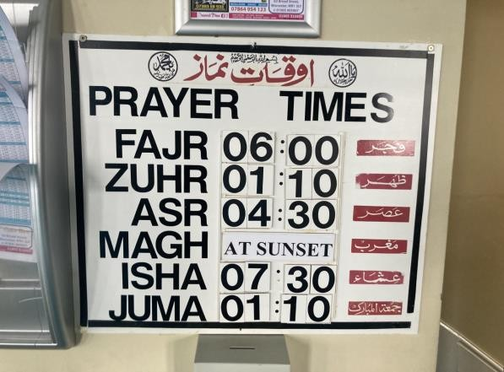
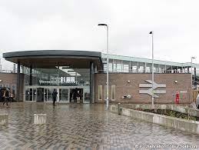
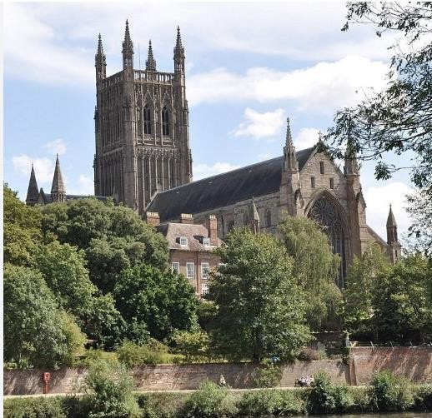
Curriculum
◆
WOW days
◆
Wow out
-
End product
◆
Visits and Visitors
Mosque Visit
Coventry Transport Museum
St James Church
Worcester Parkway
Station
Worcester
Cathedral
Themes and Topics in
Year 2
Autumn
Term 1
Autumn
Term 2
Spring

Term 1
Spring
Term 2
Summer
Term 1
Summer
Term 2
Houses and
Homes
(
Comparing
Tudor,
Victorian
and Modern
Homes)
The great
Fire of
London
Where do
we live?
(
Continents
and Oceans)
A Voyage of
Discovery
(
A history of
transport)
Significant
People
(
In the
history of
transport
and
invention)
We are
The UK
United
(
Kingdom
countries,
cities and
seas)
Mi casa
su

casa
Contrasting
(
Mexico and
England)

Reading
◆
Shared reading
-

during lessons, everyday, cross
-
curricular.
◆
Library Book
–

changed weekly in library sessions
◆
Reading books
–

RWInc

books will be sent home for your
child to read and discuss with you.
◆
Accelerated Reader is introduced in year 2.
Reading at home
◆
Record book title and write a response to the book they
have read
◆
Regular reading is expected
–

house points given on a
Friday.
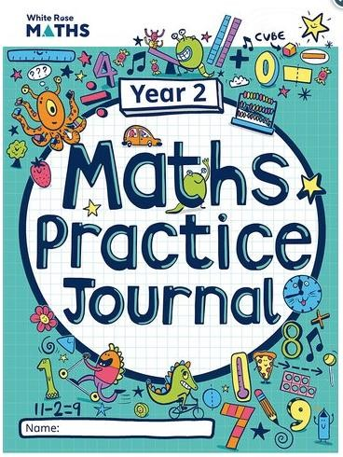
Maths
◆
All aspects of maths are covered (Shape, measures, time,
calculations, problem solving)
◆
We complete oral, practical and written work
◆
Children taught daily
◆
CPA (concrete, pictorial, abstract) maths policy
◆
Mastery Approach (keep up not catch up)
◆
White Rose is followed
◆
Mad Maths Monday
–

Problem Solving Lesson
◆
Maths fluency taught in addition to normal
◆
maths lessons.


Personal Skills and Learning Behaviours
- -Three rules- RRS- Be Respectful, Be Responsible, Be safe  · Positive Behaviour Praised through:

- - Good News Cards- children going above and beyond expectations- sent home on same day stating which behaviour being shown

- - Congratulations Cards

- - House Points
Behaviour Policy
◆
After consultation with staff, children and parents
a new Behaviour Policy
was implemented 2023/24
.
◆
A restorative approach
has

been

implemented

to

allow for the children to reflect more on their
behaviour and take more ownership.
◆
The

Policy will have 6 steps that include:

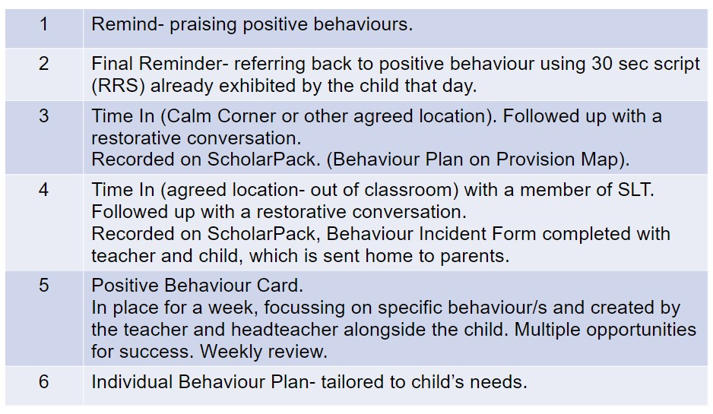

- Spelings sent home Friday to be tested on Monday, the worksheet will be retrieval of lessons delivered in class.

- RWInc book sent home on a Friday to be read over the weekend. Some children may also have Red Word sheets included with their books.
- We would love you to read everyday for 10 minutes to help with fluency.

Homework
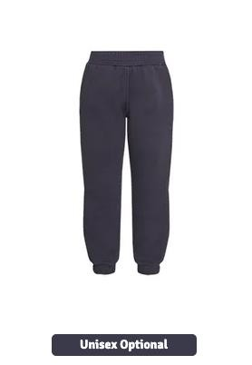
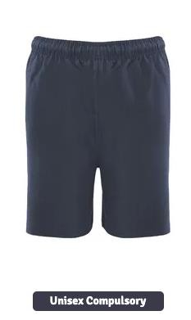
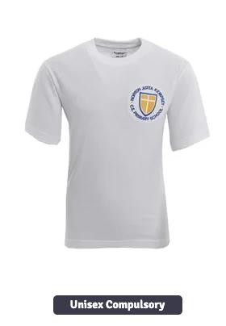
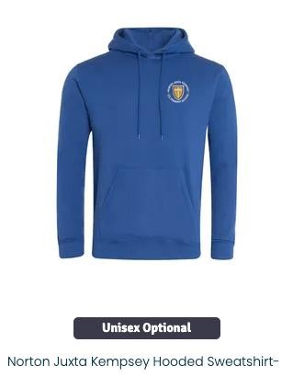
Uniform
◆
Uniform list on website
◆
NJK PE kit
–

worn on PE days
◆
Winter kit
-

joggers/leggings (navy blue),
◆
PE t
-
shirt
–

logo
◆
New hoodie or school jumper/cardigan
◆
Named Water bottles
◆
No jewellery and earrings must be removed by pupil or
covered for PE. (please provide tape)
Communication
◆
Home School link book. Specific communication pages and
reading record pages.
◆
School web site
◆
Text Messages/Arbour parent app
◆
Newsletters emailed
◆
Specific curriculum activity enquires only via Seesaw (other
enquires via the school office)
◆
Any worries
–

please make an appointment to speak to your
child’s class teacher, in the first instance.

Questions
◆
Please email any specific questions or enquiries that have not
been answered to: office@nortonprimary.worcs.sch.uk
◆
Class webpage:
https://norto
n
-
juxt
a
-
kempsey.secur
e
-
primarysite.net/clas
s
-
pages
/
We look forward to working
with you
and your child.

