BABY IT’S COLD OUTSIDE!
YEAR 1: AUTUMN 2
_{COVERAGE:}  _{Science:}  Seasonal changes  Features of day and night including temperature  Weather associated with seasons  Floating and sinking freezing and melting – ice cube experiment  _{Maths:}  Geometry (shape)  Place Value within 20  Data Collection  Consolidation of Addition and Subtraction  _{DT/Art:}  Recycling using materials for Art  Paint mixing- hot and cold pictures  William Morris- leaf pictures  Learn about range of artists, craftsmen and designers  Recycling Art- make igloo/binoculars out of recycled materials  Use range of tools & materials to complete practical tasks  RE: What do Christians believe God is like?  What is the good news the gospel brings?  _{PSHE /RSE:}  Relationships and Anti Bullying Week  _{ICT:}  Write & test simple programs | _{KEY LANGUAGE AND VOCABULARY:}  _{discuss}  _{identify}  _{explain}  rain, sunshine, hail, snow, cloud, dryness, snow, wind, temperature  beach, coast, forest, hill, mountain valley, soil , vegetation  _{Winter, Autumn, Spring, Summer}  Equator, North Pole, South Pole  North, South, East and West; near and far | _{KNOWLEDGE AND FACT SHEET}  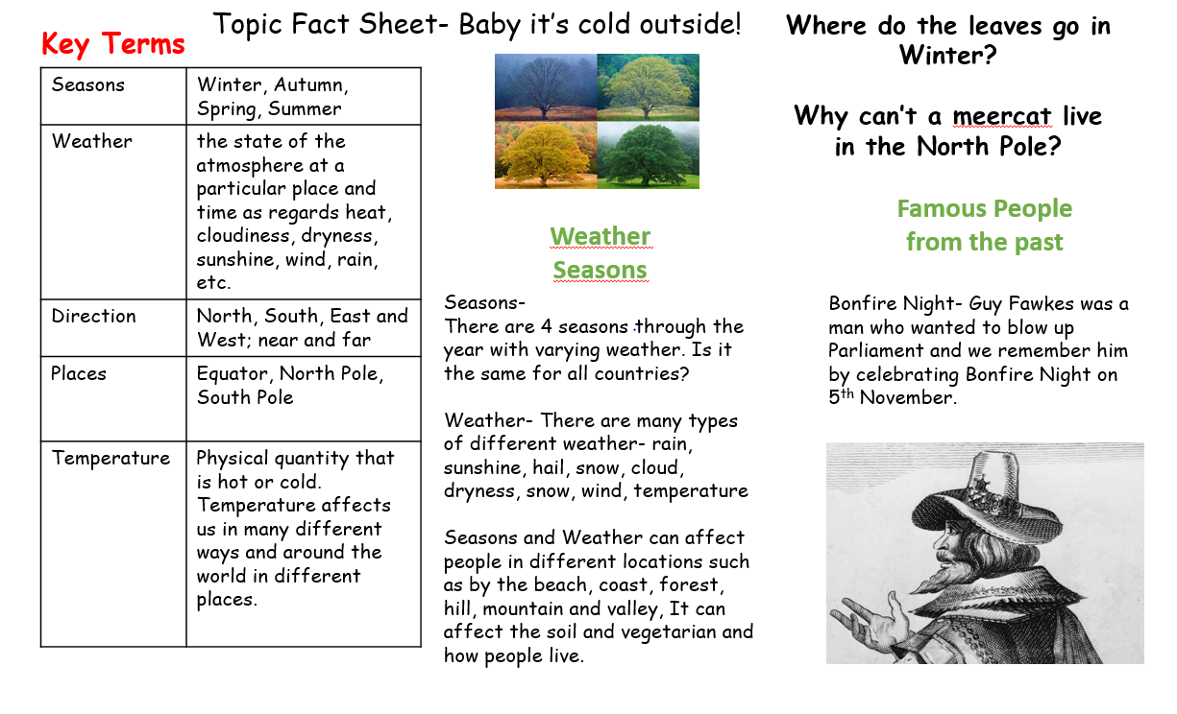  _{KEY QUESTIONS:}  _{History}  Do they appreciate that some famous people have helped our lives be better today?  Do they recognise that we celebrate certain events, such as bonfire night, because of what happened many years ago?  _{Geography}  Can they answer some questions using different resources, such as books, the internet and atlases?  Can they answer questions about the weather?  _{Can they keep a weather chart?}  Can they explain the main features of a hot and cold place?  Can they explain how the weather changes with each season?  Can they begin to explain why they would wear different clothes at different times of the year?  Can they tell something about the people who live in hot and cold places?  Can they explain what they might wear if they lived in a very hot or a very cold place?  Can they point out where the equator, north pole and south pole are on a globe or atlas?
_{KEY SKILLS AND KNOWLEDGE}
- I can observe and comment on different weather
- I can explain how weather changes
- I can test which material makes a good house.
- I can describe how weather may affect people and at different times of the year .
- I can identify and explain where places are in the world
- I discuss how famous people have helped us today
_{ENRICHMENT:}  Wow in: Guided Tour of the desert and a cold place  Wow out: Bring in bag to go on a pretend aeroplane ride | _{PUPIL LEADERSHIP:}  _{Develop talk partners}  Children to assign ‘congratulation cards’ to peers  _{Develop class monitor roles}

