YEAR 1 Spring 2 People who made our lives better
Zoom Zoom Zoom we’re going to the moon!
_{COVERAGE:}  Maths:  Length + height  Weight and Volume  Consolidation  Place Value within 50  DT/Art:  Sketches of old photos brought in  Use drawing, painting and sculpture  Evaluate existing products & own ideas  RE:  How & why do we celebrate special & sacred times? EXPRESSING  PSHE /RSE:  Health and Well being  Healthy Lifestyles  Growing and Changing  British Values: Mutual Respect: Number 1 classroom rule: Treat other people the way that you want them to treat you  ICT:  Organise, store, retrieve & manipulate data | _{KEY LANGUAGE AND VOCABULARY:}  _{after}  _{astronaut}  _{before}  _{evidence}  _{famous}  _{flight}  _{gather}  _{history}  _{launch}  _{mission}  _{scientist}  _{space}  _{Space Race}  _{tourist}  _{travel} | _{KNOWLEDGE AND FACT SHEET}  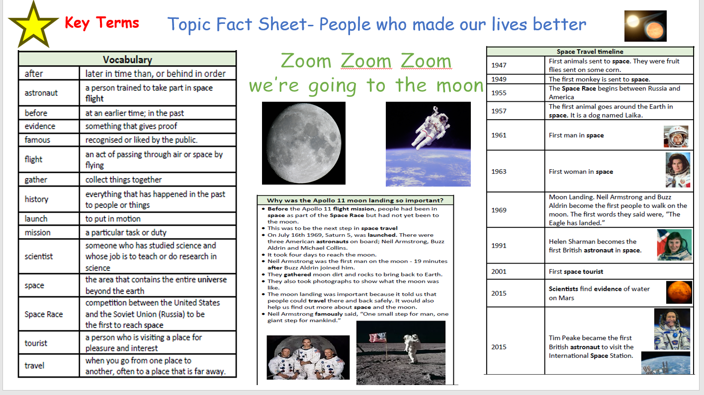  History  Do they appreciate that some famous people have helped our lives be better today?  •Can they put up to three objects in chronological order (recent history)?  •Can they use words and phrases like: old, new and a long time ago?  •Do they know that some objects belonged to the past?  •Can they ask and answer questions about old and new objects?  •Can they spot old and new things in a picture?  •Can they answer questions using an artefact/ photograph provided?  •Can they give a plausible explanation about what an object was used for in the past?
_{KEY SKILLS AND KNOWLEDGE}
- I can place key events in the history of space travel on a timeline
- I can compare this timeline to the timeline of my family
- _{I can compare two astronauts}
- I can explain what caused the 1969 Moon Landing
- I can explain what effects the 1969 Moon Landing had on history
- I can use words such as before, after, past, present, then and now to describe the history of space travel
- I understand that people have changed our lives for the better today
_{ENRICHMENT:}  Wow in: Mysterious object has arrived!  _{Wow out: Now Press Play} | _{PUPIL LEADERSHIP:}  School council reps acknowledged  Children to assign ‘congratulation cards’ to peers  _{Develop class monitor roles}

