YEAR 1 Summer 1
Life on the farm
_{COVERAGE:}  Maths:  Multiplication and division  Fractions  Position and Direction  DT/Art: Inspired by William Morris – sketching of plants & printing.  RE: CREATION  Who do Christians say made the world?  PSHE /RSE:  Wider World  Rights and Responsibilities page  Wider World  Environment  (Link to Geography)  British Values: Democracy: Empowering the children to make choices and come to agreements  ICT:  Organise, store, retrieve & manipulate data | _{KEY LANGUAGE AND VOCABULARY:} | _{KNOWLEDGE AND FACT SHEET}  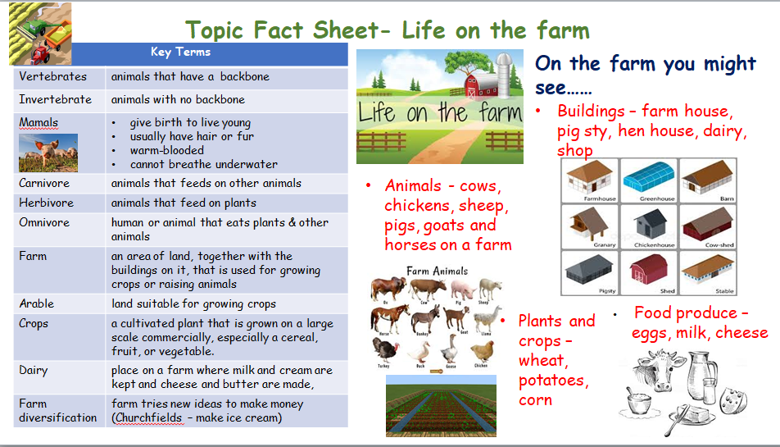  Key Questions  - Can they point out some of the differences between different animals?  - Can they classify common animals? (birds, fish, amphibians, reptiles, mammals, invertebrates)  - Can they describe how an animal is suited to its environment?  - Can they name the parts of an animal’s body?  - Can they name a range of domestic animals?  - Can they classify animals by what they eat? (carnivore, herbivore, omnivore)  - Can they compare the bodies of different animals?  - Can they sort some animals by body covering, eg, scales, fur and skin?  - Can they describe what happens on a farm?  - Can they discuss how farming has changed over time?  - What is specialist farming?  - What are the different types of farming?  - What happens locally on our farms?  - Can you describe your local area?
  Vertebrates
  Invertebrate
  Vertebrate
  Backbone
  Herbivore
  Omnivore
  Carnivore
  Mammals
  Crops
  Dairy
  Farm diversification
  Grow
  Pasturisation
  Farm
  Arable
KEY SKILLS AND KNOWLEDGE
Science: Animals (including humans)
- I can identify and label a variety of common animals (fish, amphibians, reptiles, birds and mammals)
- I know carnivores, herbivores and omnivores
- I know how to care for pets

History
- I know some changes within living memory.
- I know some significant historical events, people and places in their own locality.

_{ENRICHMENT:}  Wow in: Virtually speak to a farmer  _{Wow out: Now Press Play} | _{PUPIL LEADERSHIP:}  School council reps acknowledged  Children to assign ‘congratulation cards’ to peers  _{Develop class monitor roles}

